**STAR AGILE DEVOPS COURSE**

**MODULE 4**

**JENKINS ASSIGNMENT:**

**Assignment 1 :**

You are working for an MNC - Software Solutions company as a DevOps Engineer and Company would want you to establish the CICD pipeline in their organization by automating various workflows. You are requested to establish the following task.

1. Setup a Jenkins server on AWS ubuntu machine.

2. Create a freestyle project.

3. Configure below git repository to code checkout. GitHub : Repo URL

4. Compile the source code using Maven

5. Execute the Junit test cases using Maven

6. Package the application as war.

7. Install the tomcat9 server on AWS ubuntu machine.

8. Deploy the packaged application on Tomcat9.

9. Verify the application after successful deployment using browser.

**ANSWERS:**

Created an Ubuntu machine and a tom cat machine

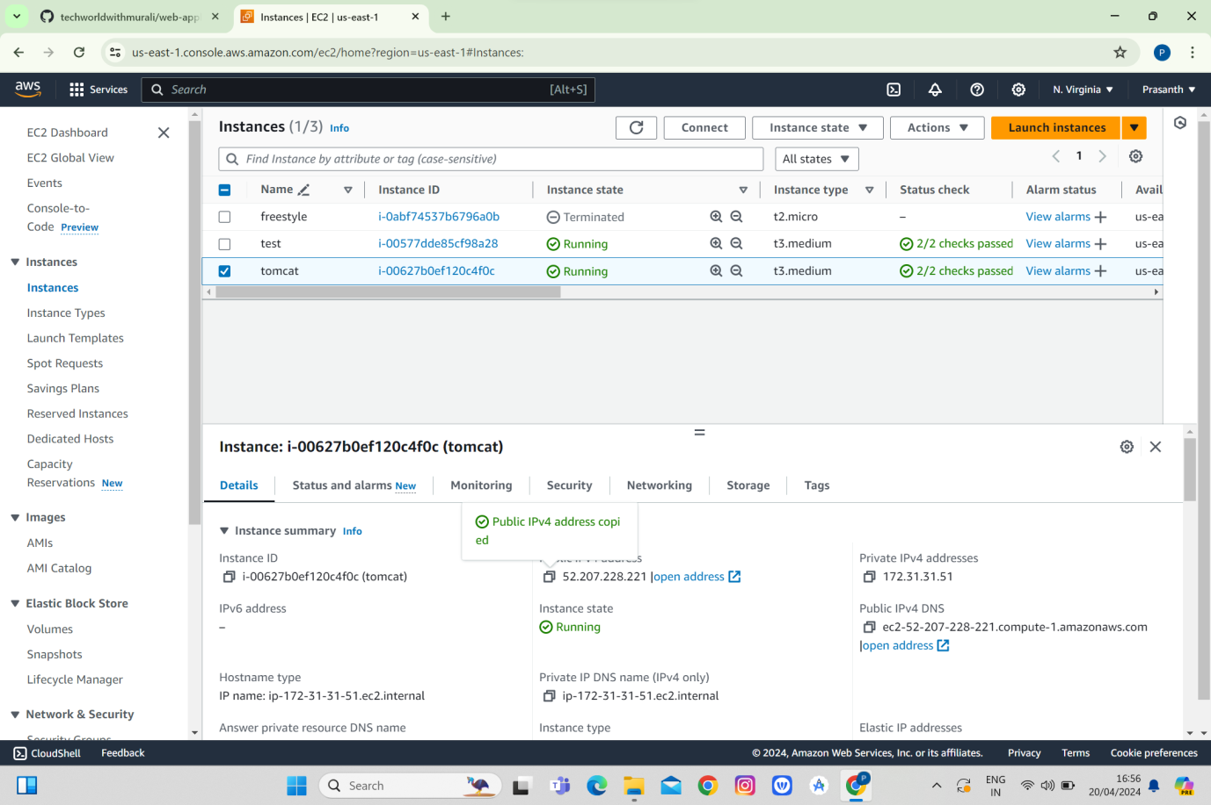

Then configured Jenkins and tomcat with changing context xm in host manager and manager and tomcat users.xml

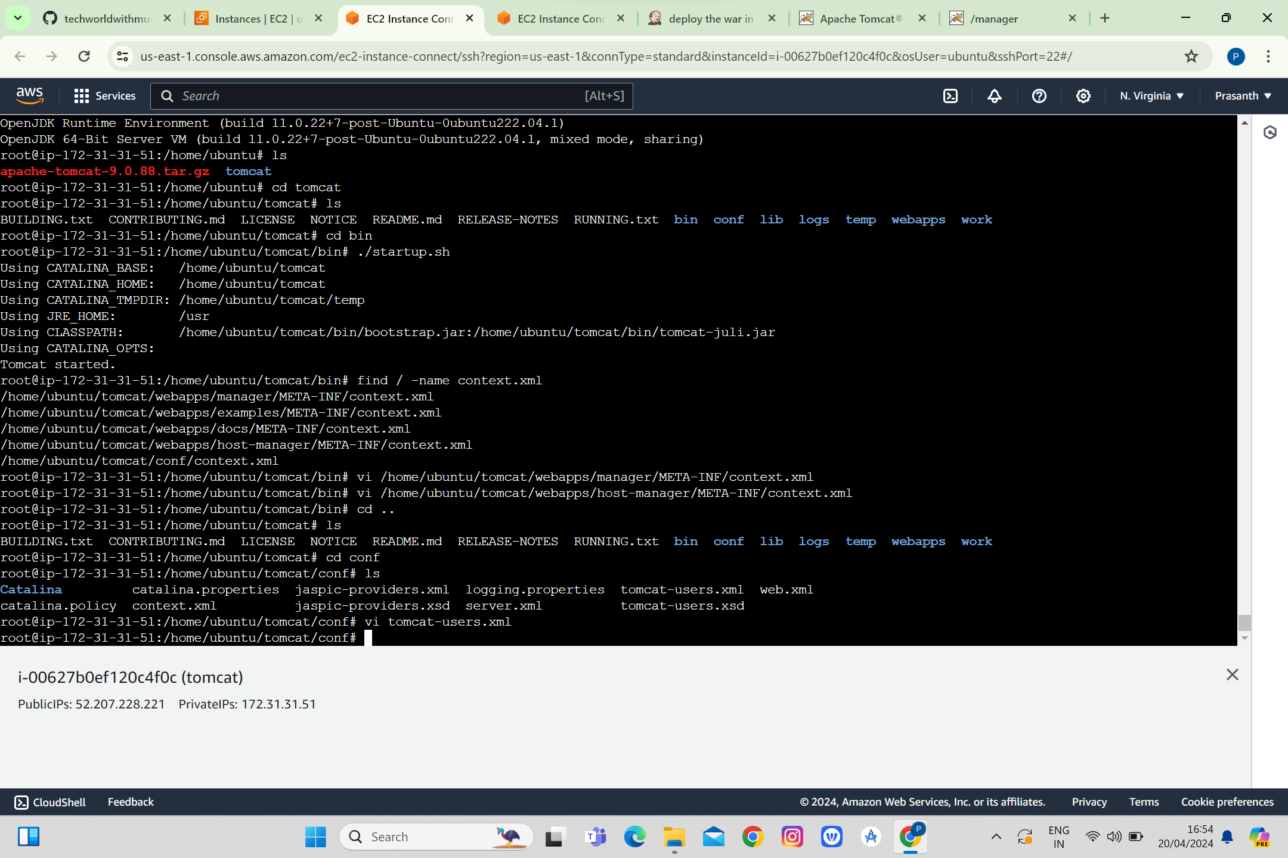

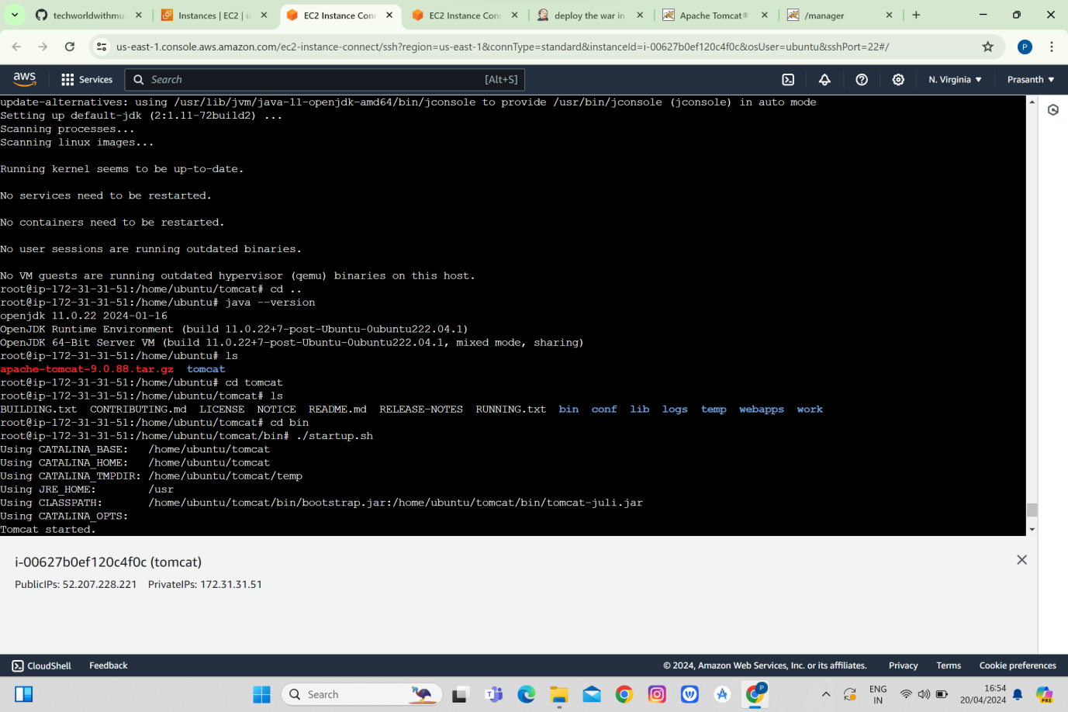

Created free style project

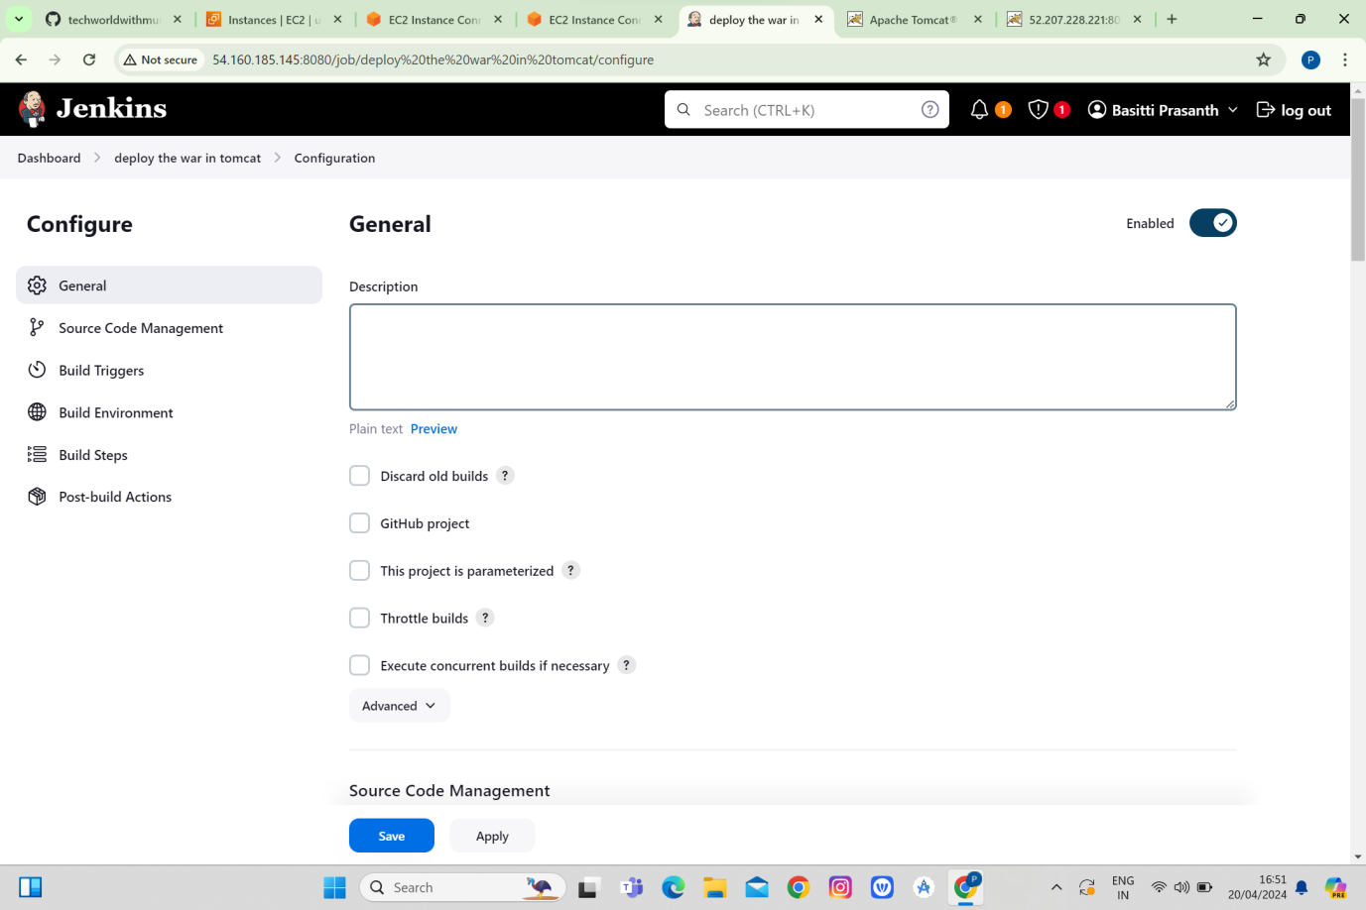

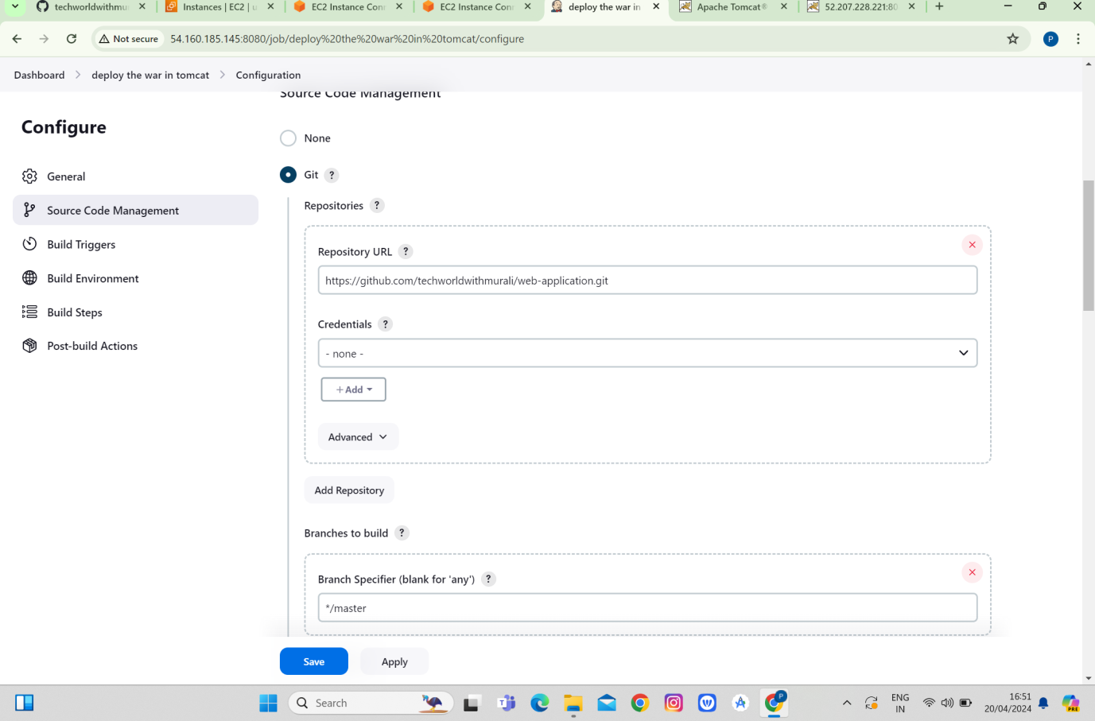

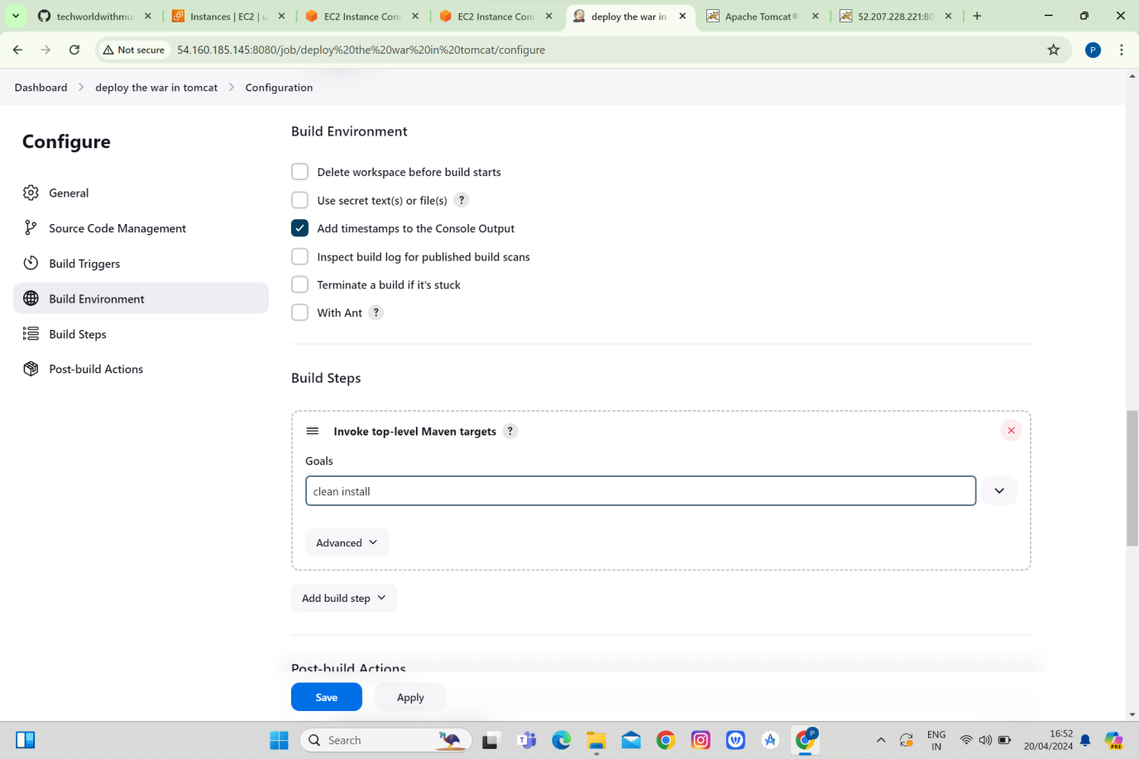

Upon running in tomcat we can find web application war file so the application is deployed.

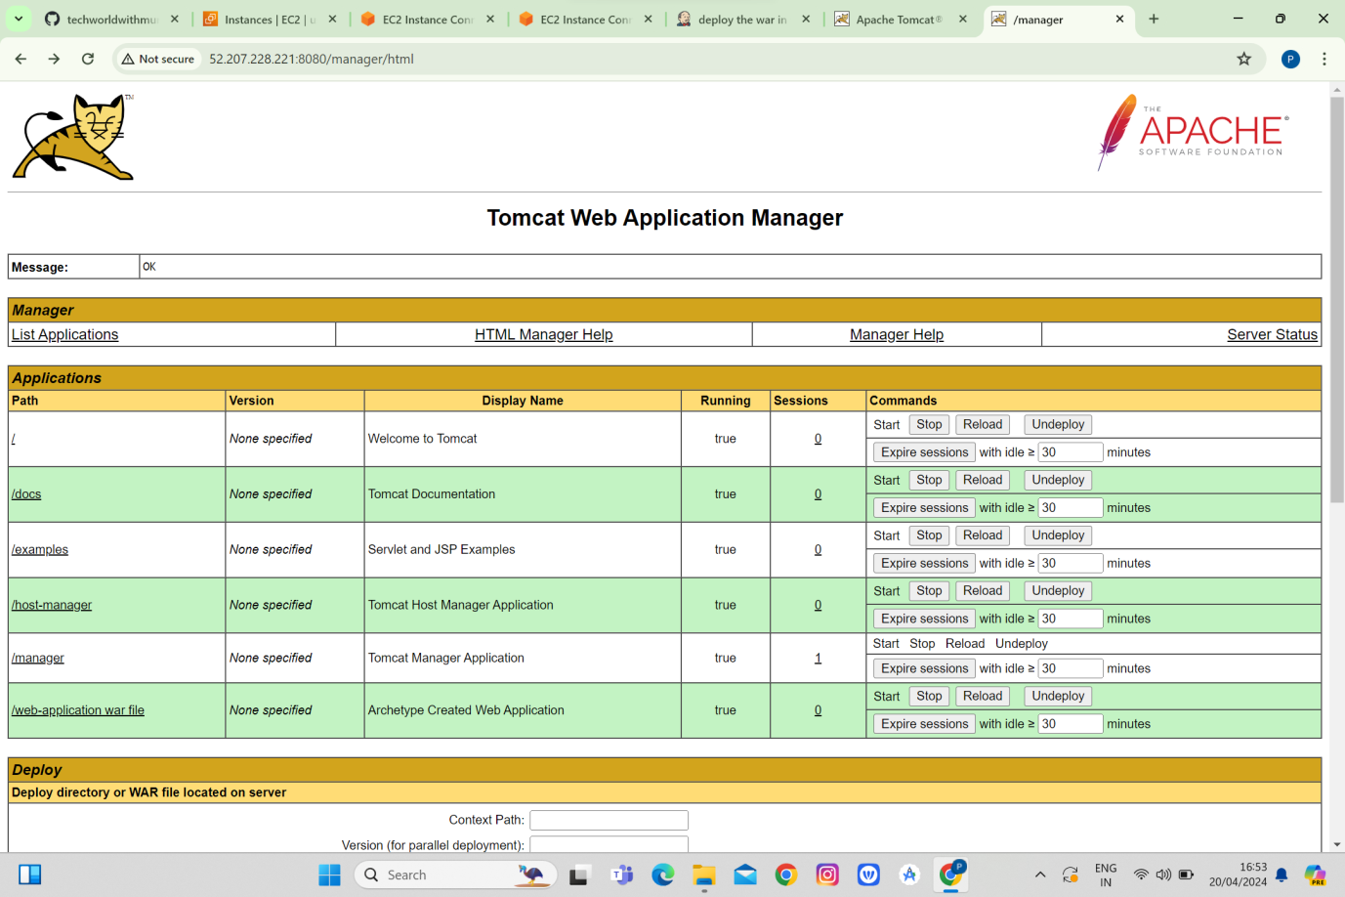

**Assignment 2:**

Adding a Slave node in Jenkins You are working for an MNC - Software Solutions company as a DevOps Engineer and Company would want you to establish the CICD pipeline in their organization by automating various workflows. As there is only one build server setup, many teams have to wait for their changes to be build. The organization would like to setup a slave node, so that workload can be shared from the master to the slave node and parallel builds can be performed. You are requested to do following action items:

1. Create an AWS EC2 Ubuntu instance. (name as Jenkins-master)

2. Setup Jenkins on this server.

3. Add another AWS EC2 ubuntu instance(name as Jenkins-slave)

4. Add this node to the Jenkins Master as Slave.

5. Configure the pipeline script from the previous assignment to run the build on the slave node.

6. Trigger the build on master and verify if the build is running on slave node or not

**ANSWERS:**

Created instances for master and slave and installed jdk in slave and Jenkins in master and connected those with the ssh connection

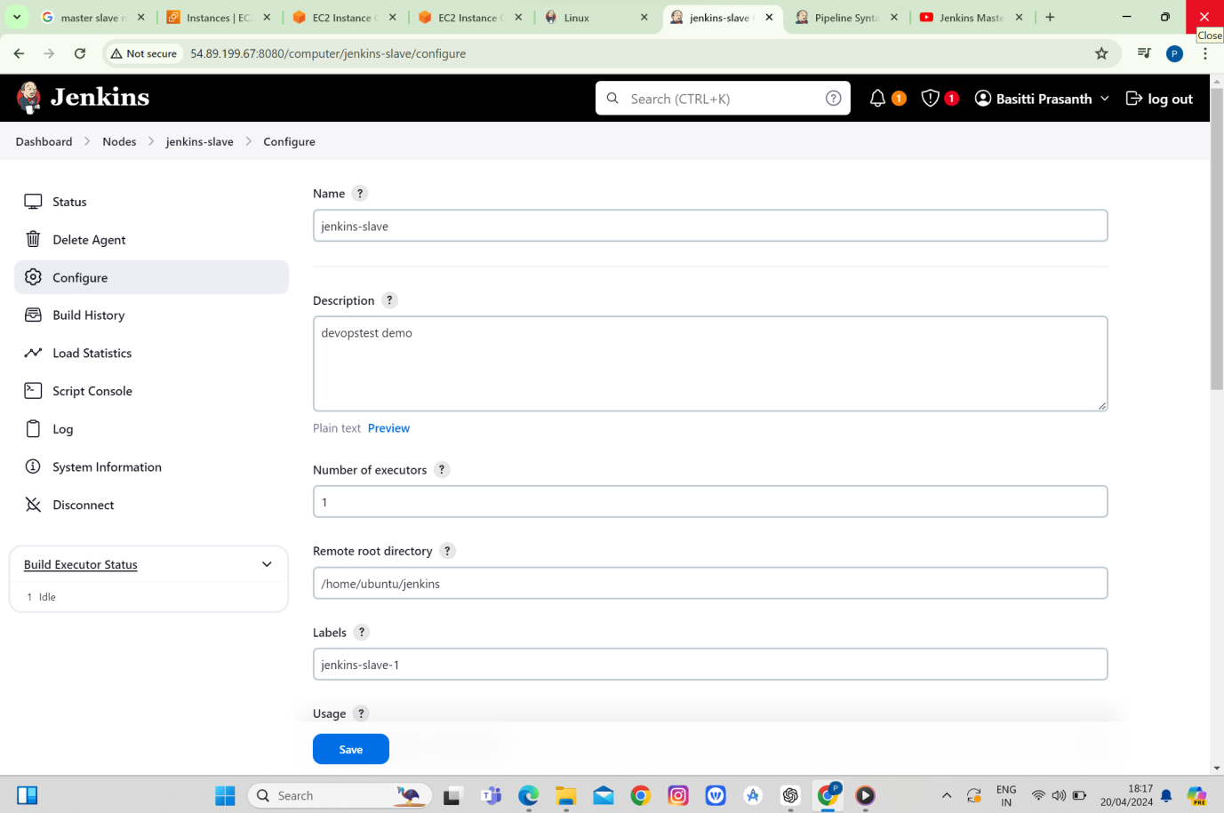

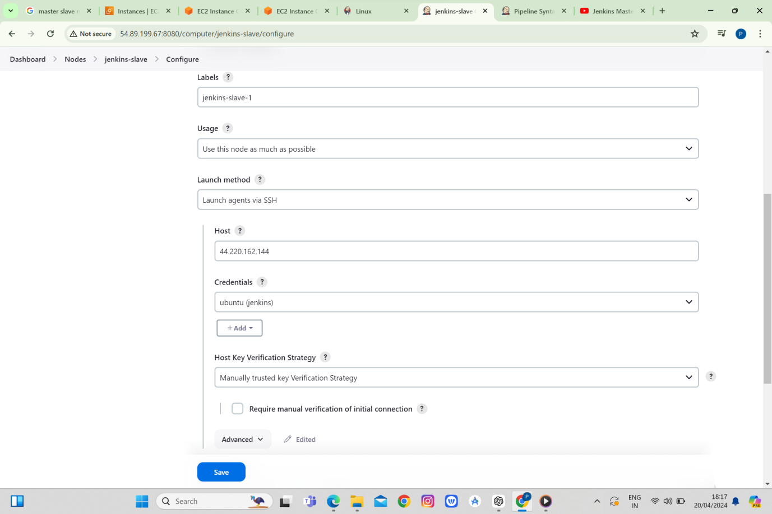

We can see the demo file here

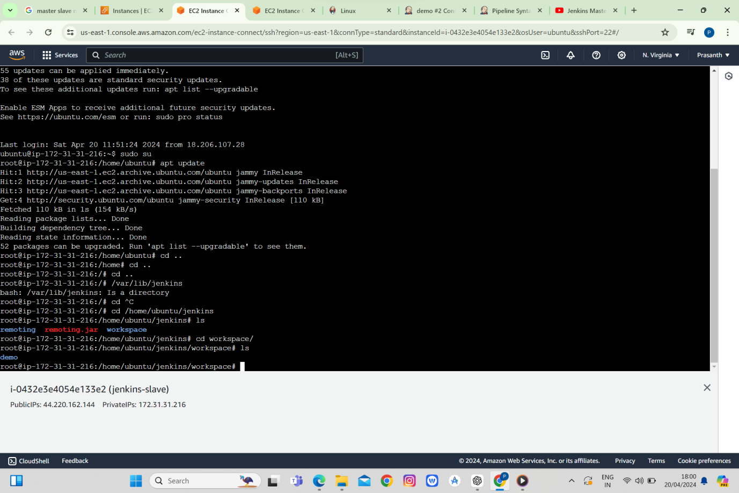

We can see the node slave connected

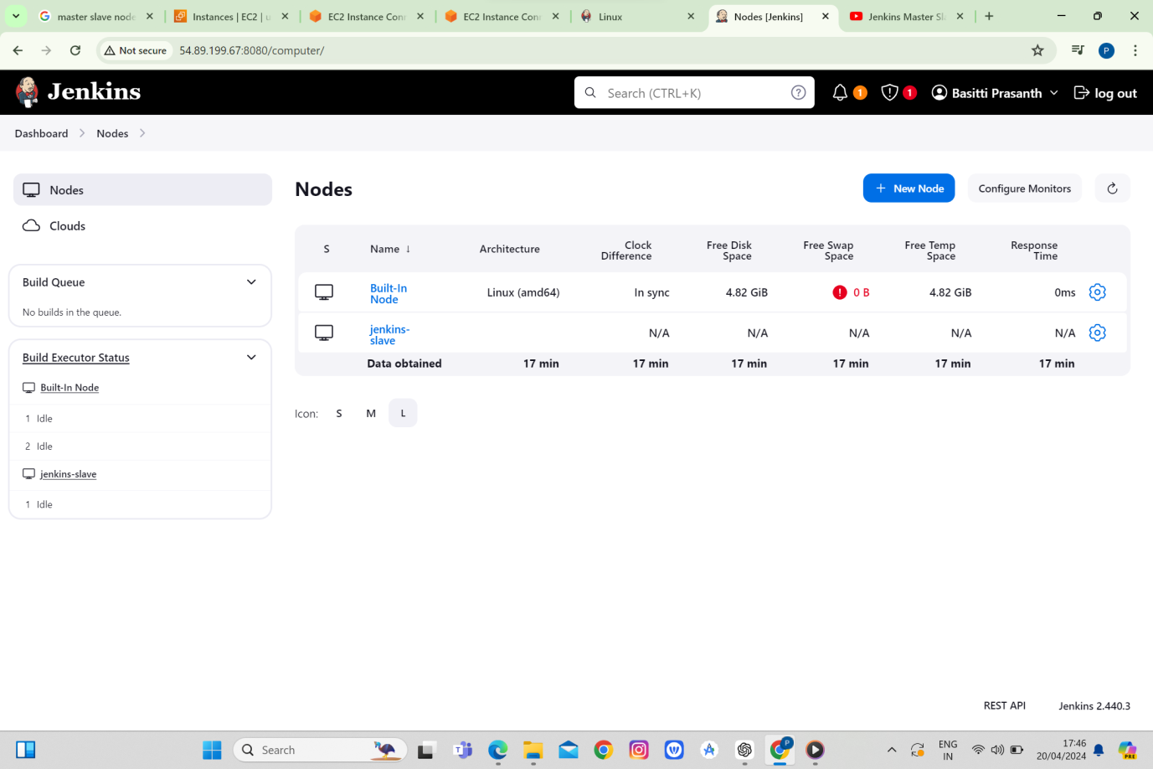

Added pipeline script to it

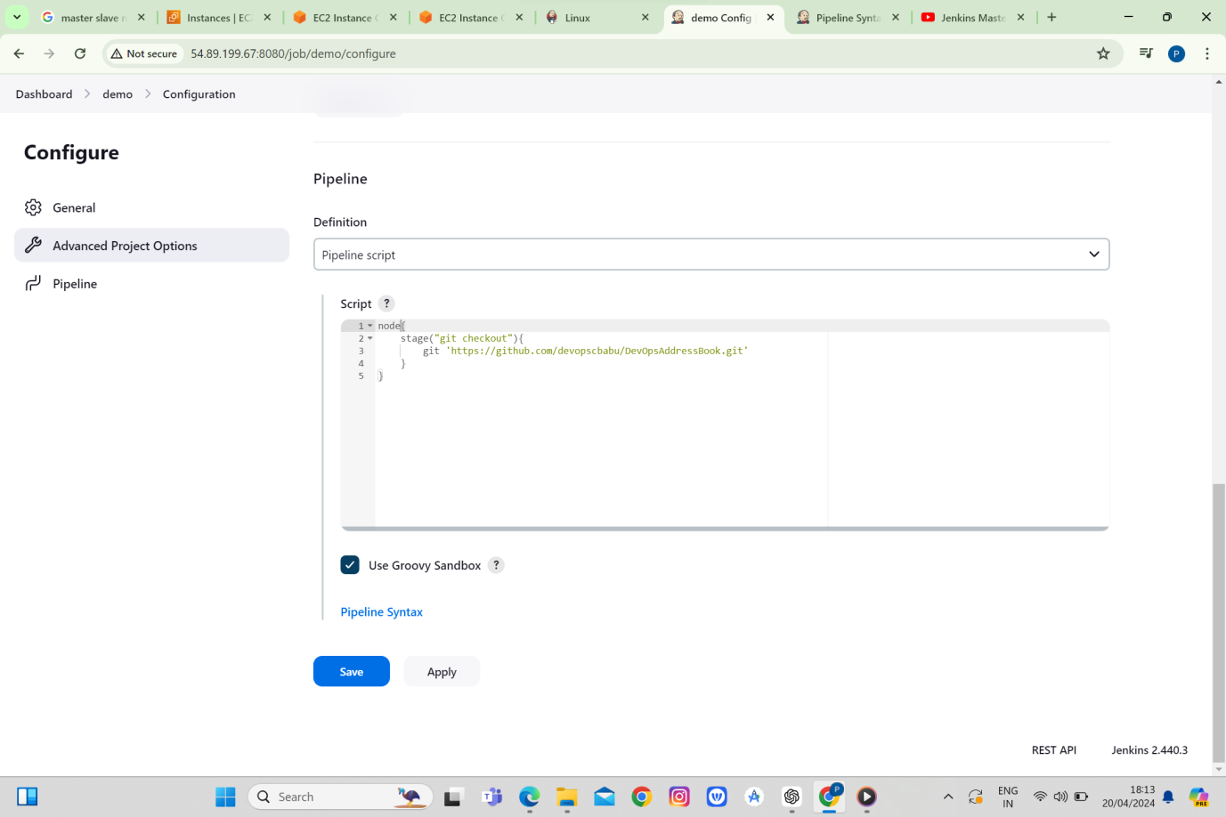

The pipeline script is build

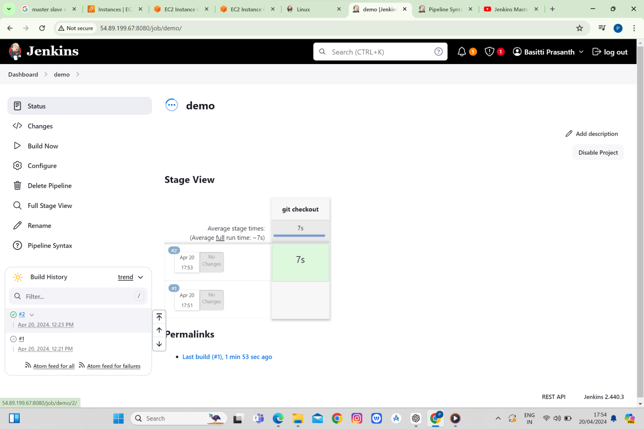

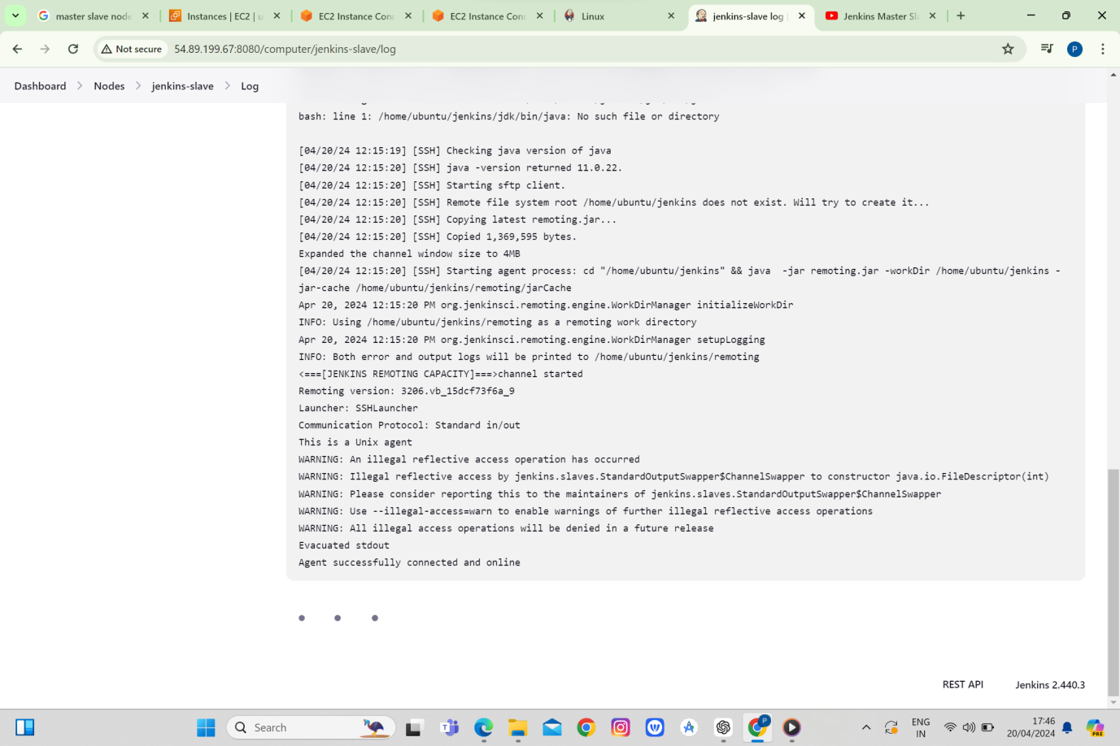

We can see the script is running on Jenkins slave

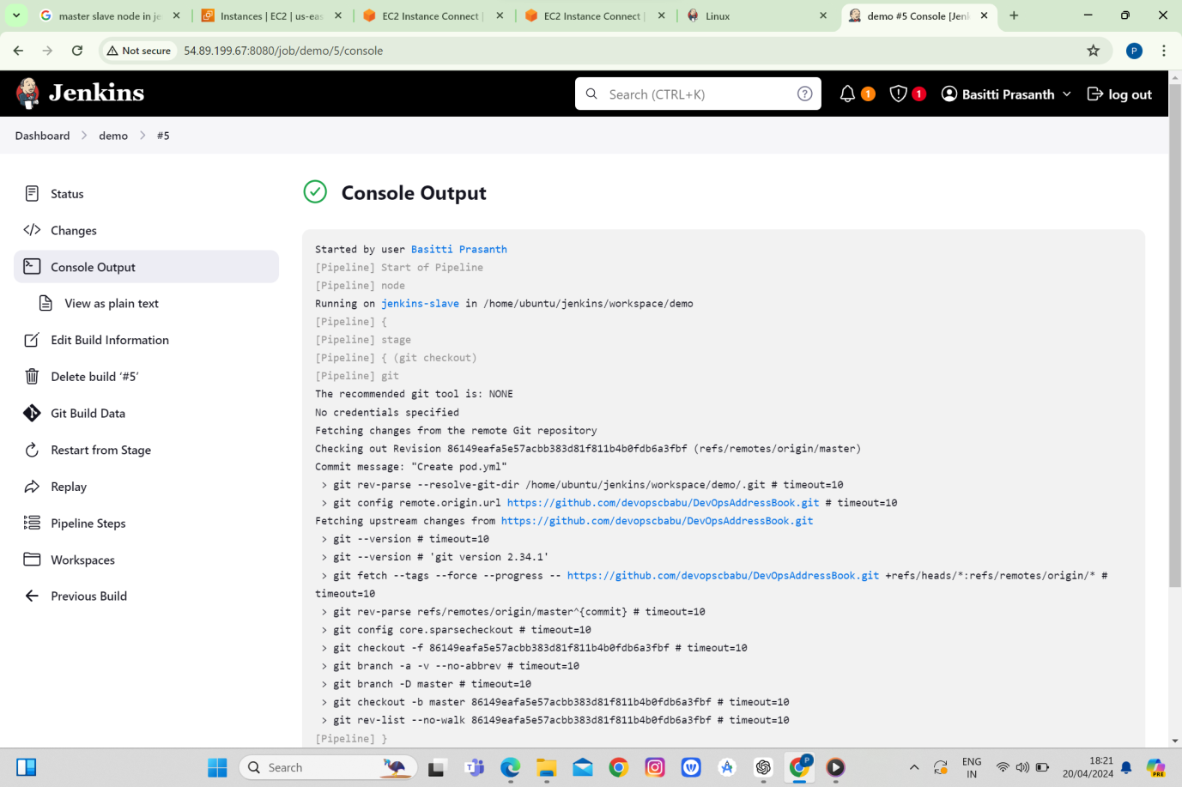

**Assignment 3 :**

You are working for an MNC - Software Solutions company as a DevOps Engineer and Company would want you to establish the CICD pipeline in their organization by automating various workflows. You are requested to establish following task.

1. Setup a Jenkins server on AWS ubuntu machine.

2. Create a pipeline project.

3. Configure below git repository to code checkout. GitHub : Repo URL

4. Compile the source code using Maven

5. Execute the Junit test cases using Maven

6. Package the application as war.

7. Install the tomcat9 server on AWS ubuntu machine.

8. Deploy the packaged application on Tomcat9.

9. Verify the application after successful deployment using browser

Created instances for the aws Ubuntu machine and installed jdk Jenkins and tomcat

**ANSWERS:**

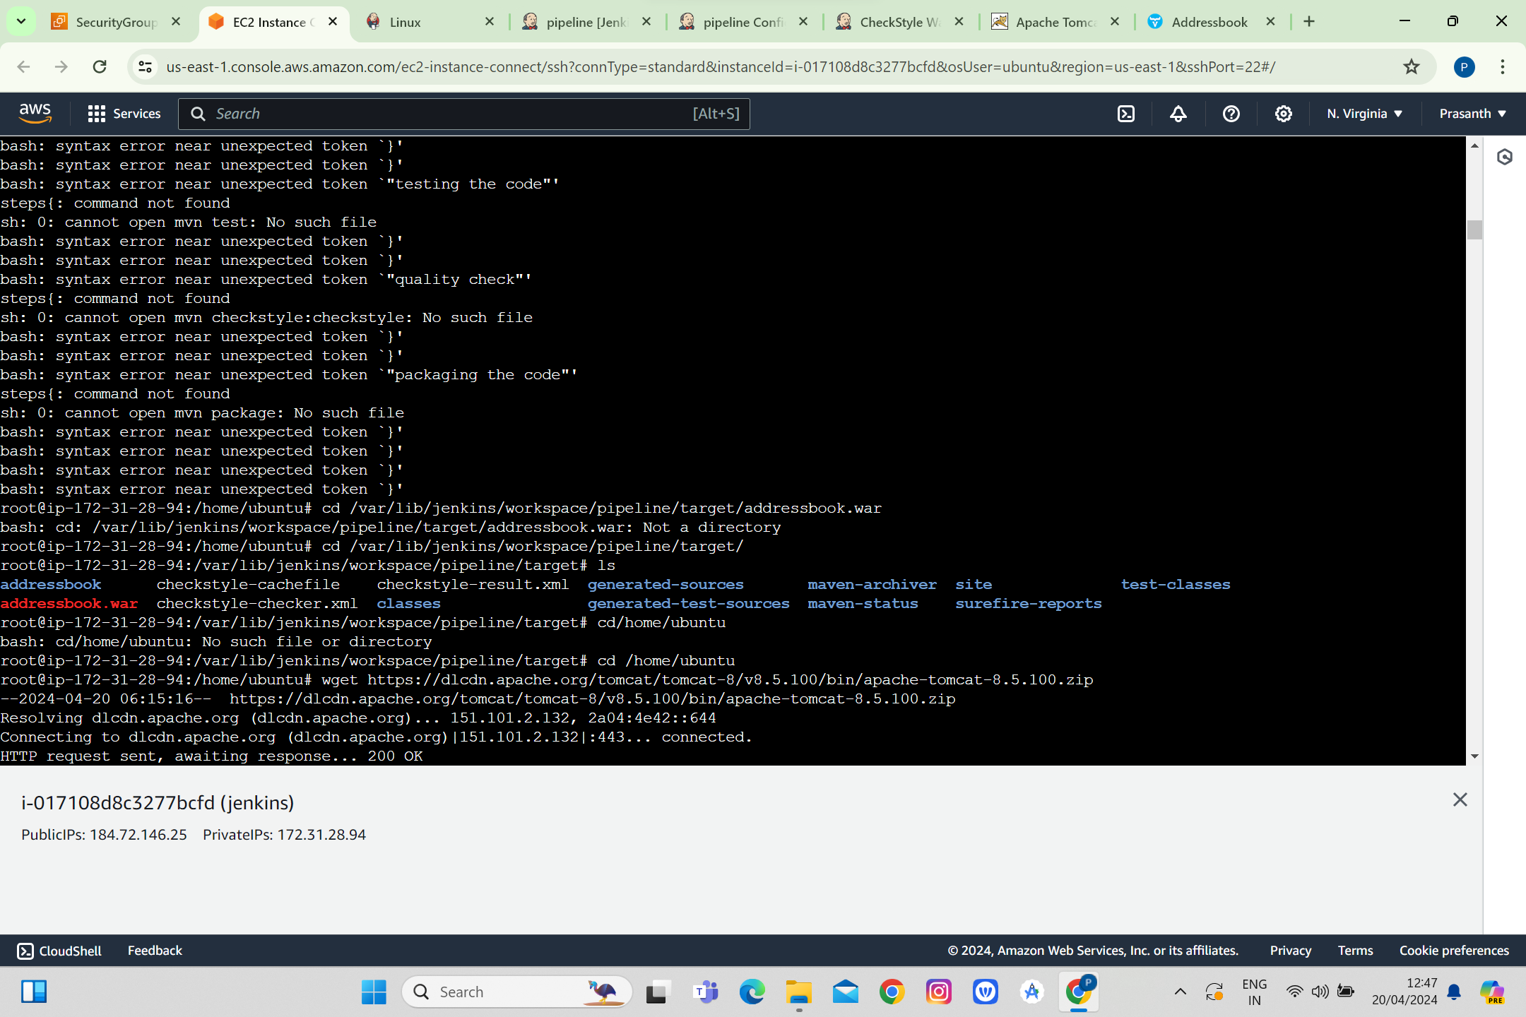

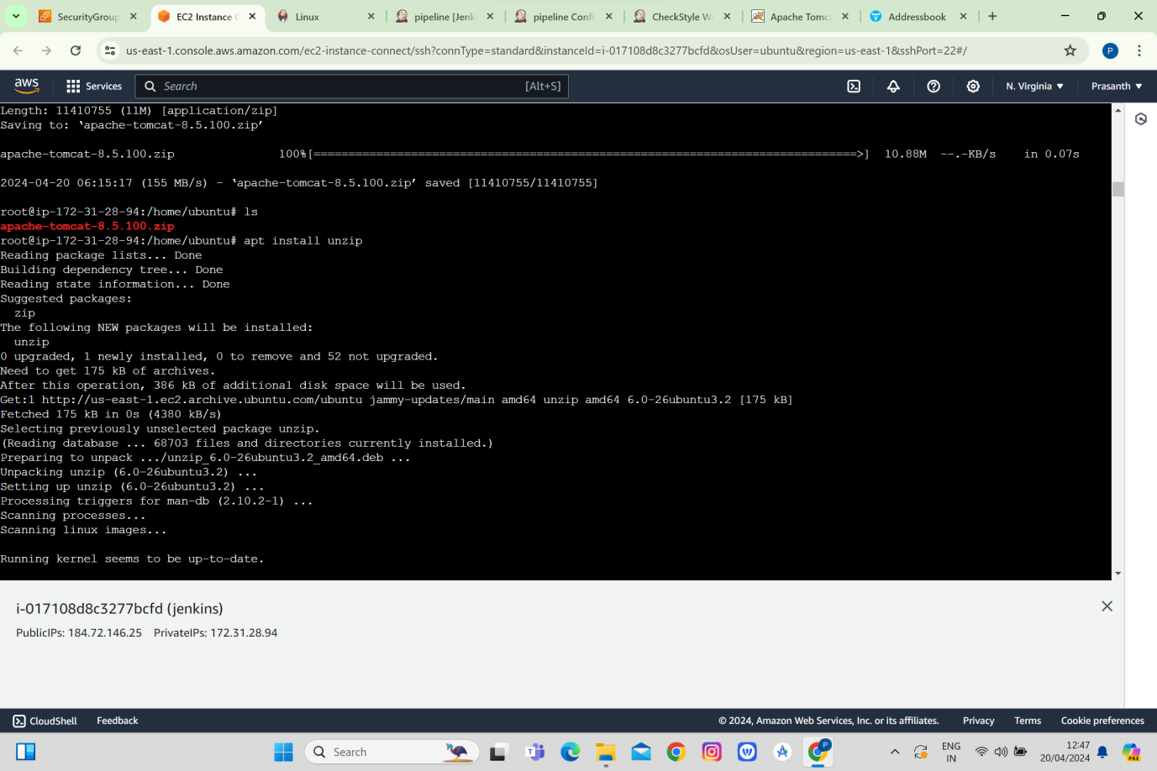

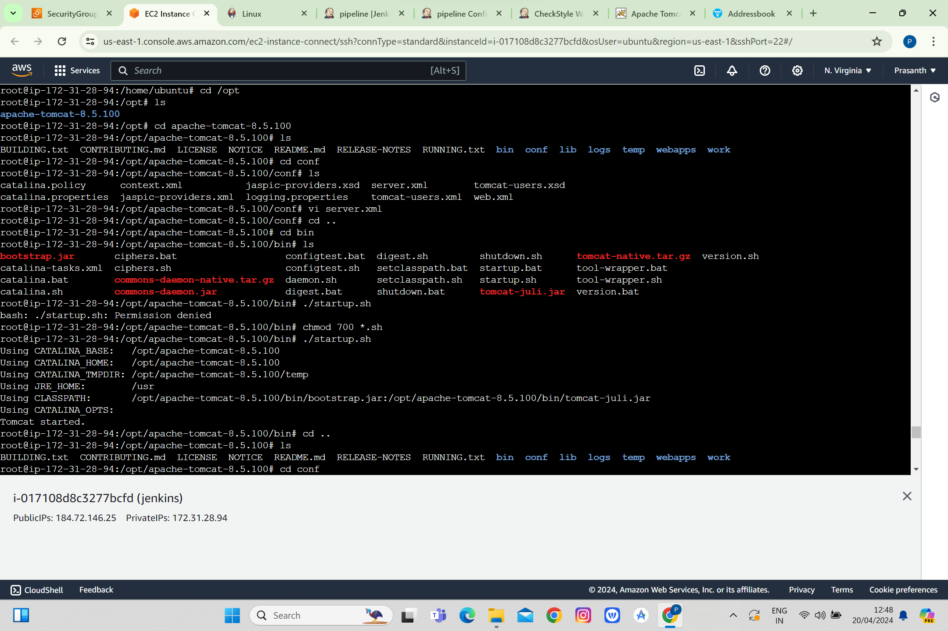

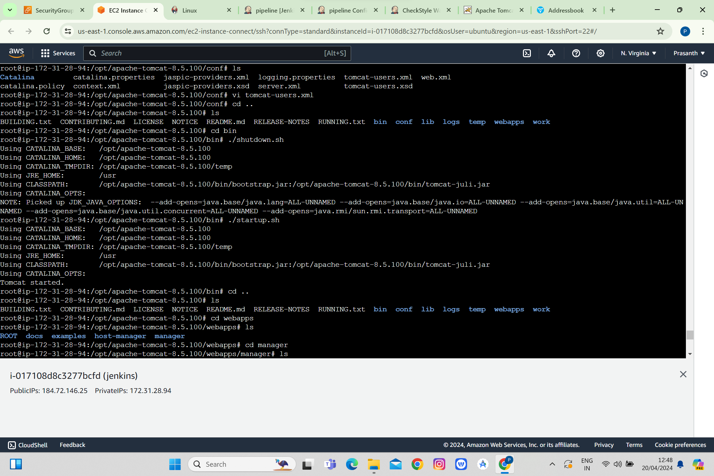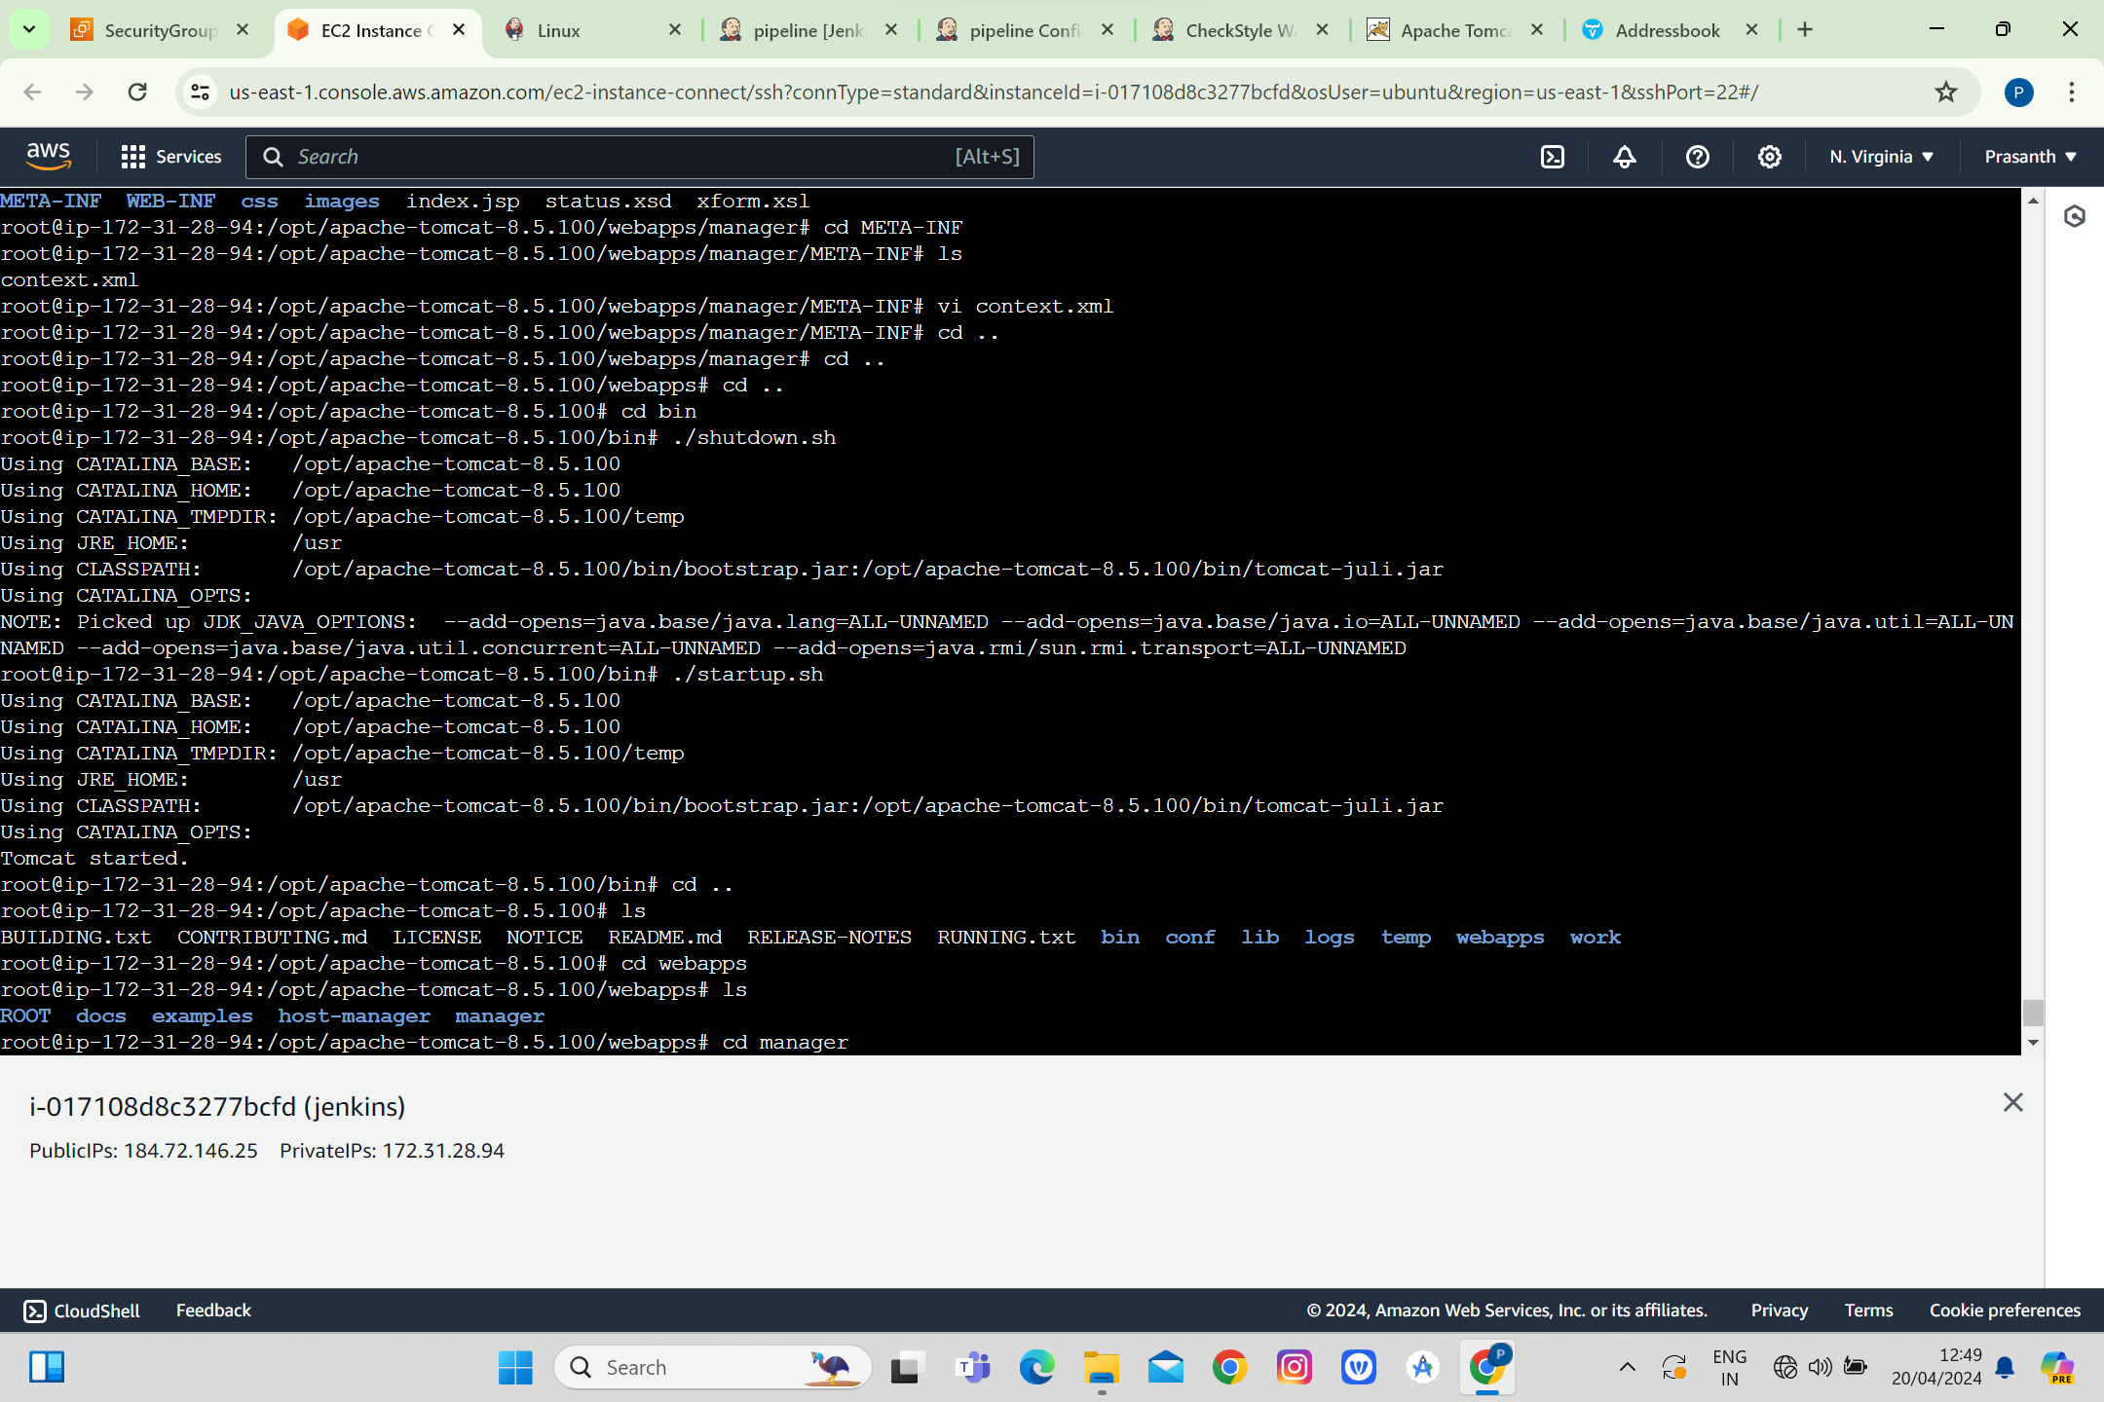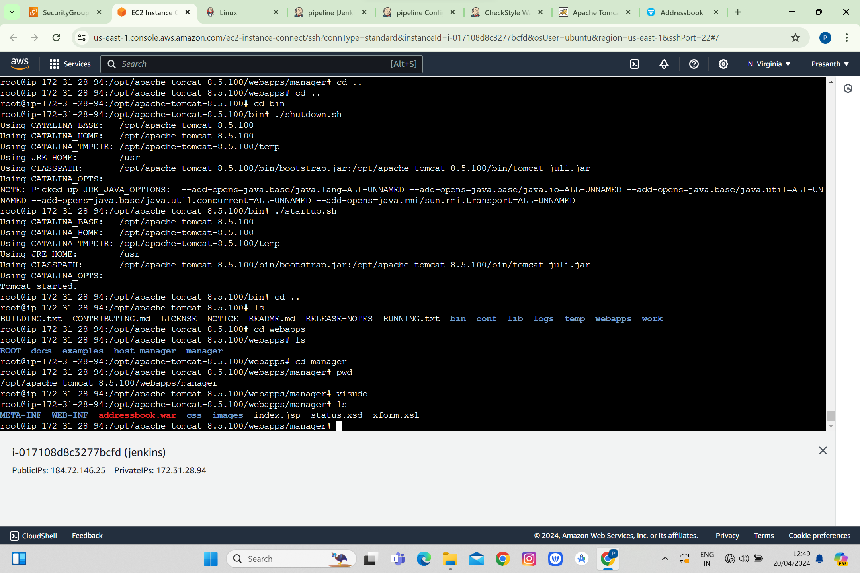

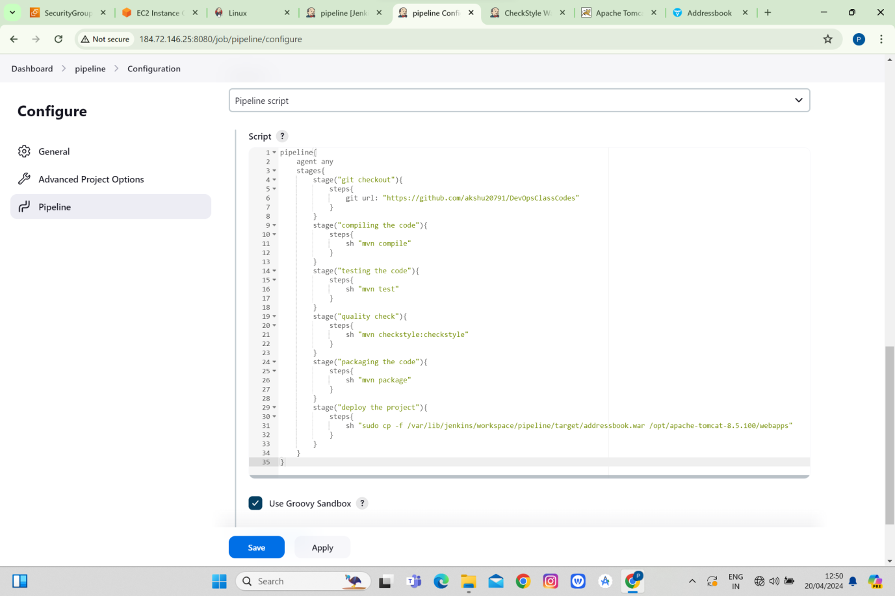

Ran the pipeline script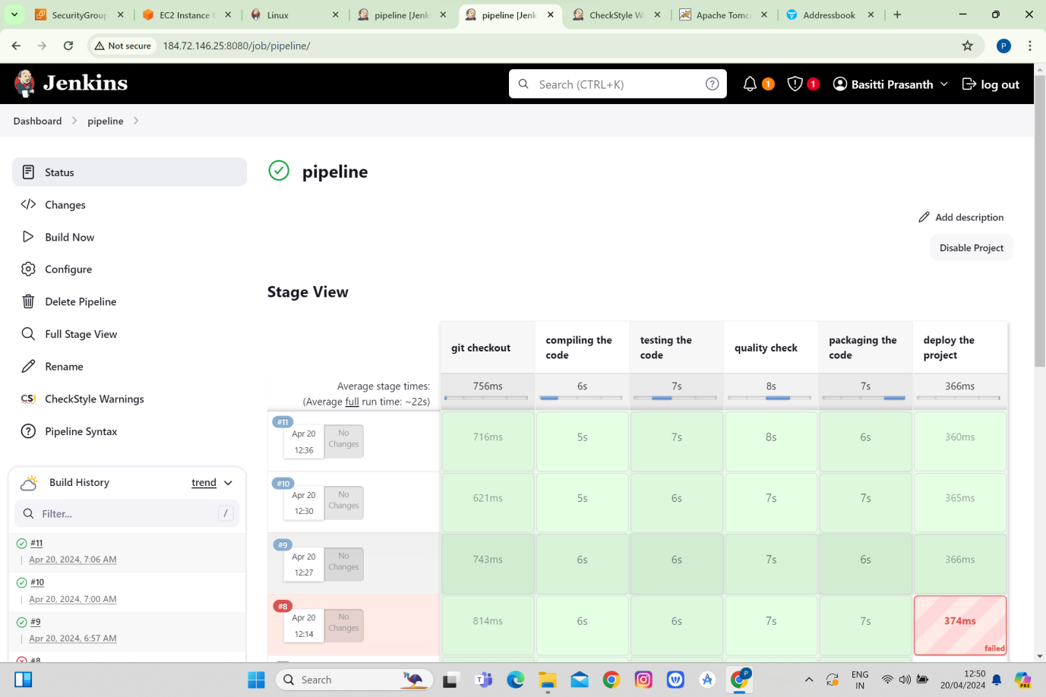

Started the tomcat server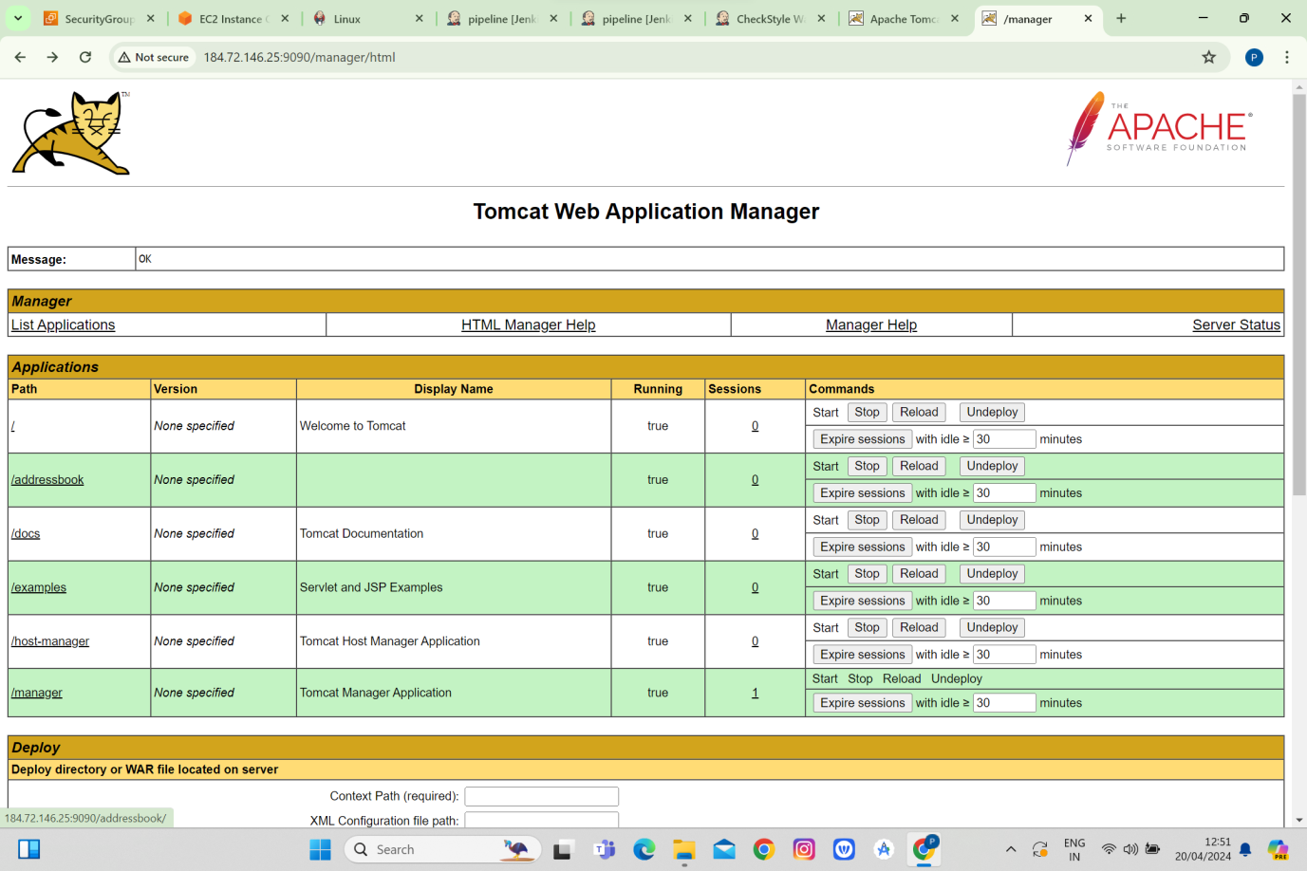

We can see the addressbook file there so the application is deployed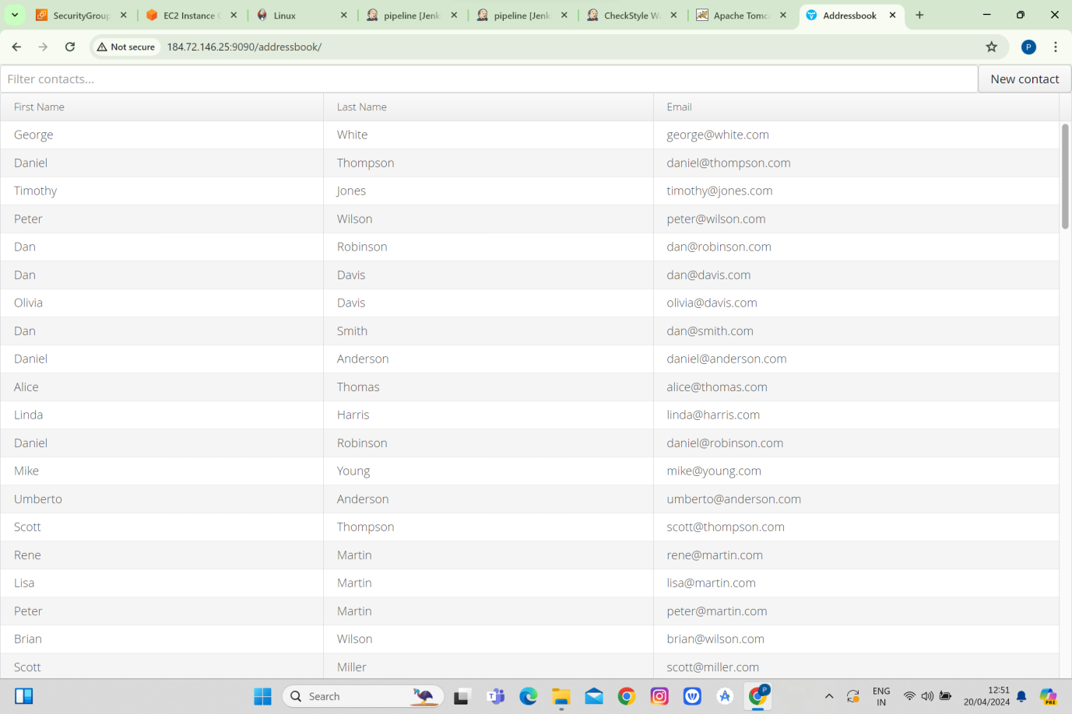

We can see reports by check style actions